**Industrial Sliding Barn Doors**

NikoTrack industrial Sliding Barn Doors uses enclosed monorail track and fittings that are low friction and easy to operate for door weights of up to 1600 kgs – 3,520 lbs. Niko offers a complete range of installation fittings and track sizes to meet extreme working conditions for heavy industrial and barn door applications. The trolleys, track and fittings systems are maintenance free, electro galvanized, modular and simple to install. The inverted track profiles protect the trolley systems from accumulations of dust, dirt and ice ensuring a smooth operation of large sliding door systems. With applications ranging from agricultural to aircraft hanger doors and numerous industrial door for applications, Niko Track offers a complete engineered solution.

**Selection of Sliding Door Uses**

**Folding sliding door track** and fittings provide a space effective solution for sliding doors, ideal for applications in patio sliding doors and partition sliding doors. Also NikoTrack folding sliding doors have been used in factories, workshops, and even schools for separating classrooms. 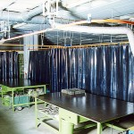The lightweight range of NikoTrack sliding door track is ideal for **sliding curtain applications**. The possibilities for applications are only limited by your imagination. NikoTrack sliding curtain track and fittings have been used in PVC strip sliding curtains, sliding curtains for welder stations, sliding netting in gymnasiums, and sliding theatre curtains.

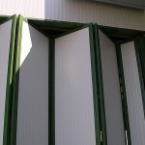NikoTrack sliding door track can be used to create **sliding partition systems** for both residential and industrial environments. NikoTrack has had applications in movable walls, sliding partitions for segmenting work areas and dividing rooms.

[Link: NikoTrack Heavy Duty Applications Catalog](http://nikotrack.com/wp-content/pdfs/NikoTrack_Heavy_Duty.pdf)

[Link: B1 Heavy Duty Sliding Door Fittings](http://nikotrack.com/wp-content/pdfs/B1-Heavy-Duty-Sliding-Door-Hardware_ver_05_16.pdf)

**Advantages of Niko Sliding Barn Door Track**

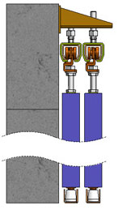The NikoTrack monorail sliding industrial doors are designed to handle working loads of up to 3,520 lbs (1600 KGs) using an enclosed monorail track systems. NikoTrack industrial sliding door track and all components are electro galvanized to meet tough working environments for both inside and outside work areas. The NikoTrack has a tapered track that automatically guides the trolley to the center of the track, moving the heaviest loads only requires a fraction of force to begin movement and even less to maintain it. There is a 100/1 weight to force ratio, so to move a 1,000 lbs of material only requires 10 lbs of force to start moving it and only 8 lbs to continue moving. Also, the NikoTracks inverted tapered track profile, there is a much less likelihood of dirt/dust/snow/ice accumulating inside of the track which will require less maintenance and ensure reliability. All fittings are zinc plate for maximum durability and protection for tough operating environments. Tracks are available in 6 meter length (19.70 feet), they are cold rolled with tapered sides designed to center the trolleys, prevent dust build up assuring smooth transfer of trolleys.[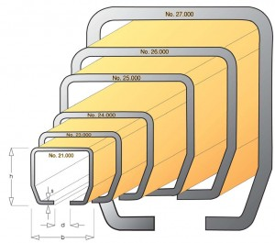](http://nikotrack.com/slidingdoors/files/2012/11/Track-Profiles.jpg)

**Technical Specifications**

[Single Track – Exterior Mounting](http://industrialslidingbarndoors.com/" \l "one)   |   [Single Track – Adjustable Exterior Wall Brackets](http://industrialslidingbarndoors.com/#two)  
[Two Sliding Doors – Double Fixed Exterior Wall Brackets](http://industrialslidingbarndoors.com/#three)   |   [Two Sliding Doors – Double Adjustable Exterior Wall Brackets](http://industrialslidingbarndoors.com/#four)  
[Ceiling Support Systems](http://industrialslidingbarndoors.com/#five)

**Single Track – Exterior Mounting**

[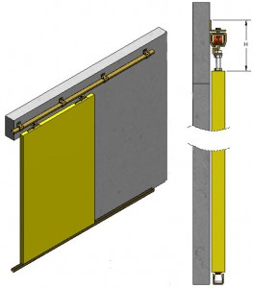](http://nikotrack.com/slidingdoors/files/2012/11/single-exterior-lg.jpg)

Single Track – Exterior Mounting

|  |  |  |  |  |
| --- | --- | --- | --- | --- |
| Niko Profile No. | Double wheel hanger SWL kg | Door weight max (2 hangers) SWL kg | Door weight max (2 hangers) Electric Operation SWL kg | Door weight max for harmonica and folding doors SWL kg |
| 21.000 | 45 | 90 | – | 22 |
| 23.000 | 100 | 200 | 100 | 50 |
| 24.000 | 200 | 400 | 200 | 100 |
| 25.000 | 300 | 600 | 300 | 150 |
| 26.000 | 600 | 1200 | 600 | 300 |
| 27.000 | 1000 | 2000 | 1200 | – |

|  |  |  |
| --- | --- | --- |
| **Wall Support Bracket w/Double Wheel Hanger** | | |
| Niko Profile No. | Wall Support Bracket | Distance H Max / Min (mm) |
| 21.000 | 21.B01 | 112 / 98 |
| 23.000 | 24.B01 | 148 / 121 |
| 24.000 | 24.B01 | 175 / 146 |
| 25.000 | 25.B01 | 215 / 188 |
| 26.000 | 26.B01 | 330 / 242 |
| 27.000 | 27.B01 | 400 / 306 |

[*Back to Top*](http://industrialslidingbarndoors.com/#tops)

**Single Track – Adjustable Exterior Wall Brackets**

[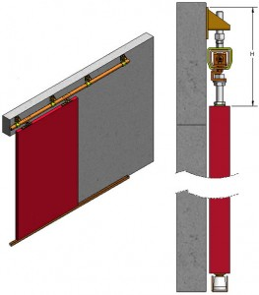](http://nikotrack.com/slidingdoors/files/2012/11/single-exterior-2-lg.jpg)

Single Door – Adjustable Exterior Wall Brackets

|  |  |  |  |  |
| --- | --- | --- | --- | --- |
| Niko Profile No. | Double wheel hanger SWL kg | Door weight max (2 hangers) SWL kg | Door weight max (2 hangers) Electric Operation SWL kg | Door weight max for harmonica and folding doors SWL kg |
| 21.000 | 45 | 90 | – | 22 |
| 23.000 | 100 | 200 | 100 | 50 |
| 24.000 | 200 | 400 | 200 | 100 |
| 25.000 | 300 | 600 | 300 | 150 |
| 26.000 | 600 | 1200 | 600 | 300 |
| 27.000 | 1000 | 2000 | 1200 | – |

|  |  |  |  |
| --- | --- | --- | --- |
| **Adjustable Wall Bracket with  Adjustable Bracket & Double Wheel Hangers** | | | |
| Niko Profile No. | Adjustable  Wall Bracket | Adjustable  Bracket | Distance H Max / Min (mm) |
| 21.000 | 21.B05 | 21.B04 | 170 / 130 |
| 23.000 | 24.B05 | 23.B04 | 245 / 185 |
| 24.000 | 24.B05 | 24.B04 | 260 / 185 |
| 25.000 | 26.B05 | 25.B04 | 345 / 245 |
| 26.000 | 26.B05 | 26.B04 | 510 / 290 |

[*Back to Top*](http://industrialslidingbarndoors.com/#tops)

**Two Sliding Doors – Double Fixed Exterior Wall Brackets**

[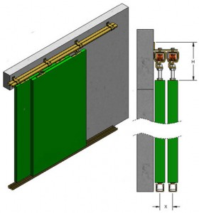](http://nikotrack.com/slidingdoors/files/2012/11/double-exterior-lg.jpg)

Two sliding doors – double fixed exterior wall brackets

|  |  |  |  |  |
| --- | --- | --- | --- | --- |
| Niko Profile No. | Double wheel hanger SWL kg | Door weight max (2 hangers) SWL kg | Door weight max (2 hangers) Electric Operation SWL kg | Door weight max for harmonica and folding doors SWL kg |
| 21.000 | 45 | 90 | – | 22 |
| 23.000 | 100 | 200 | 100 | 50 |
| 24.000 | 200 | 400 | 200 | 100 |
| 25.000 | 300 | 600 | 300 | 150 |
| 26.000 | 600 | 1200 | 600 | 300 |
| 27.000 | 1000 | 2000 | 1200 | – |

|  |  |  |  |
| --- | --- | --- | --- |
| **Double Wall Bracket with Double Wheel Hangers** | | | |
| Niko Profile No. | Double  Wall Bracket | Distance H Max / Min (mm) | Distance X (mm) |
| 23.000 | 23.B31 | 165 / 135 | 50 |
| 24.000 | 24.B31 | 195 / 165 | 60 |
| 25.000 | 24.B31 | 195 / 165 | 90 |
| 26.000 | 25.B31 | 220 / 195 | 85 |

[*Back to Top*](http://industrialslidingbarndoors.com/#tops)

**Two Sliding Doors – Double Adjustable Exterior Wall Brackets**

[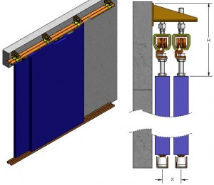](http://nikotrack.com/slidingdoors/files/2012/11/double-exterior-2-lg.jpg)

Two Sliding Doors – Double Adjustable Exterior Wall Brackets

|  |  |  |  |  |
| --- | --- | --- | --- | --- |
| Niko Profile No. | Double wheel hanger SWL kg | Door weight max (2 hangers) SWL kg | Door weight max (2 hangers) Electric Operation SWL kg | Door weight max for harmonica and folding doors SWL kg |
| 21.000 | 45 | 90 | – | 22 |
| 23.000 | 100 | 200 | 100 | 50 |
| 24.000 | 200 | 400 | 200 | 100 |
| 25.000 | 300 | 600 | 300 | 150 |
| 26.000 | 600 | 1200 | 600 | 300 |
| 27.000 | 1000 | 2000 | 1200 | – |

|  |  |  |  |  |
| --- | --- | --- | --- | --- |
| **Double Adjustable Wall Bracket with  Adjustable Bracket & Double Wheel Hangers** | | | | |
| Niko Profile No. | Double Adjustable Wall Bracket | Adjustable Bracket | Distance H Max / Min (mm) | Distance X Max / Min (mm) |
| 21.000 | 21.B06 | 21.B04 | 175 / 140 | 70 / 40 |
| 23.000 | 24.B06 | 23.B04 | 245 / 185 | 115 / 50 |
| 24.000 | 24.B06 | 24.B04 | 260 / 185 | 110 / 60 |
| 25.000 | 26.B06 | 25.B04 | 345 / 245 | 145 / 85 |
| 26.000 | 26.B06 | 26.B04 | 510 / 290 | 135 / 105 |
| 27.000 | 27.B06 | 27.B04 | 575 / 365 | 120 / 118 |

[*Back to Top*](http://industrialslidingbarndoors.com/#tops)

**Ceiling Support Systems**

[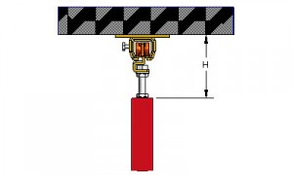](http://nikotrack.com/slidingdoors/files/2012/11/ceiling-support-bracket-lg.jpg)

Ceiling Support Bracket with Double Wheel Hanger

|  |  |  |  |
| --- | --- | --- | --- |
| **Ceiling Support Bracket with Double Wheel Hanger** | | | |
| Niko Profile No. | Ceiling  Support Bracket | Distance H Max / Min (mm) |  |
| 21.000 | 21.B02 | 89 / 74 |  |
| 23.000 | 23.B02 | 121 / 93 |  |
| 24.000 | 24.B02 | 140 / 110 |  |
| 25.000 | 25.B02 | 173 / 145 |  |
| 26.000 | 26.B02 | 278 / 190 |  |
| 27.000 | 21.B02 | 337 / 243 |  |

[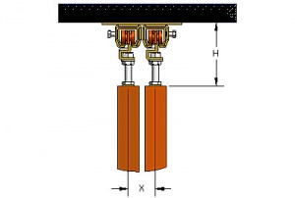](http://nikotrack.com/slidingdoors/files/2012/11/ceiling-bracket-double-lg.jpg)

Double Ceiling Bracket with Double Wheel Hanger

|  |  |  |  |
| --- | --- | --- | --- |
| **Double Ceiling Bracket with Double Wheel Hanger** | | | |
| Niko Profile No. | Adjustable  Wall Bracket | Distance H Max / Min (mm) | Distance X (mm) |
| 23.000 | 23.B32 | 89 / 74 | 50 |
| 24.000 | 24.B32 | 121 / 93 | 60 |
| 24.000 | 24.B34 | 140 / 110 | 90 |
| 25.000 | 25.B32 | 173 / 145 | 85 |

**Sliding Door Animations**

[Single Track, Single Door](http://industrialslidingbarndoors.com/#single-single)   |   [Single Track, Multiple Doors](http://industrialslidingbarndoors.com/#single-multiple)   |   [Double Track](http://industrialslidingbarndoors.com/#double-track)   |   [Triple Track](http://industrialslidingbarndoors.com/#triple-track)  
[Folding Doors, End Sliding](http://industrialslidingbarndoors.com/#folding)   |   [Stacking Sliding Doors](http://industrialslidingbarndoors.com/#stacking-sliding)   |   [Stacking Sliding Doors Round Corner](http://industrialslidingbarndoors.com/#stacking-corner)

**Straight Sliding Doors – Single Track, Single Door**



Straight Sliding Doors — Single Track

**Straight Sliding Doors – Single Track, Multiple Doors**



Straight Sliding Doors – Single Track, Multiple Doors

[*Back to Top*](http://industrialslidingbarndoors.com/#top)

**Straight Sliding Doors – Double Track, Multiple Doors**



Straight Sliding Doors – Double Track, Multiple Doors

[*Back to Top*](http://industrialslidingbarndoors.com/#top)

**Straight Sliding Doors – Triple Track, Multiple Doors**

Straight Sliding Doors - Triple Track, Multiple Doors

Straight Sliding Doors – Triple Track, Multiple Doors

[*Back to Top*](http://industrialslidingbarndoors.com/#top)

**Folding Doors – End Sliding**



Folding Doors – End Sliding

[*Back to Top*](http://industrialslidingbarndoors.com/#top)

**Stacking Sliding Doors**



Stacking Sliding Doors

[*Back to Top*](http://industrialslidingbarndoors.com/#top)

**Stacking Sliding Doors Round Corner**



Stacking Sliding Doors Round Corner

### Sliding Door Fittings

[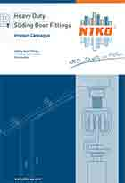](http://nikotrack.com/wp-content/pdfs/B1-Heavy-Duty-Sliding-Door-Hardware_ver_05_16.pdf)

B1 Heavy Duty Sliding Door Fittings

Heavy duty door fittings for sliding doors in wood, steel or aluminium, folding doors and harmonica doors with many panels.

* Moveable panels for outdoor shops
* Partitions for large rooms
* Heavy curtains
* Scenery and theater curtains
* Sliding gates on angle or square guide rail
* Garage doors with counter-weights
* Sliding airtight doors for freezing chambers
* Sliding doors around the corner...

**[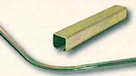](http://industrialslidingbarndoors.com/files/2012/11/track-profile.jpg)**

Track Profiles & Track Bends

**[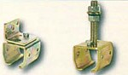](http://industrialslidingbarndoors.com/files/2012/11/track-support-bracket.jpg)**

Track Support Brackets

**[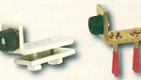](http://industrialslidingbarndoors.com/files/2012/11/track-wall-end-stop.jpg)**

Track & Wall End Stops

**[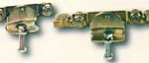](http://industrialslidingbarndoors.com/files/2012/11/sliding-door-wheelhanger.jpg)**

Wheel Hangers for Sliding Doors

**[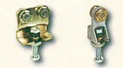](http://industrialslidingbarndoors.com/files/2012/11/folding-door-wheelhanger.jpg)**

Wheel Hangers for Folding & Rotating Doors

**[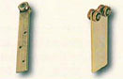](http://industrialslidingbarndoors.com/files/2012/11/special-wheel-hanger.jpg)**

Special Wheel Hangers

**[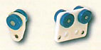](http://industrialslidingbarndoors.com/files/2012/11/curtain-wheel-hanger.jpg)**

Wheel Hangers for Curtains

**[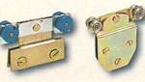](http://industrialslidingbarndoors.com/files/2012/11/glass-wheel-hanger.jpg)**

Wheel Hangers for Glass

**[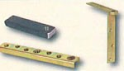](http://industrialslidingbarndoors.com/files/2012/11/bracket-hanging-panel.jpg)**

Brackets for Hanging Panels

**[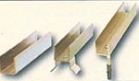](http://industrialslidingbarndoors.com/files/2012/11/guide-track-bends.jpg)**

Guide Tracks & Guide Track Bends

**[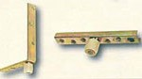](http://industrialslidingbarndoors.com/files/2012/11/brackets-w-rollers-guidetra.jpg)**

Brackets with Rollers for Guide Tracks

**[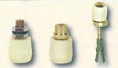](http://industrialslidingbarndoors.com/files/2012/11/roller-guides-guidetracks.jpg)**

Roller Guides for Guide Tracks

**[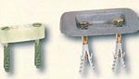](http://industrialslidingbarndoors.com/files/2012/11/special-guides.jpg)**

Special Guides

**[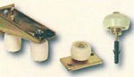](http://industrialslidingbarndoors.com/files/2012/11/sliding-door-guides.jpg)**

Guides for Sliding Doors

**[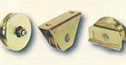](http://industrialslidingbarndoors.com/files/2012/11/bottom-rollers.jpg)**

Bottom Rollers